**Experiment 2.3**

**Student Name:   Gaurav Kumar                                UID: 22MCC20177**

**Branch:   CC-DevOps                                                        Section/Group: 1/B**

**Semester:   I                                                               Date of Performance: 17/10/2022**

**Subject Name: ADBMS                     Subject Code: 22CAP-647**

1. **Task to be done:**

Generate the following two result sets:

1. Query an alphabetically ordered list of all names in OCCUPATIONS, immediately followed

by the first letter of each profession as a parenthetical (i.e.: enclosed in parentheses).

For example: AnActorName(A), ADoctorName(D), AProfessorName(P), and ASingerName(S).

1. Query the number of ocurrences of each occupation in OCCUPATIONS. Sort the occurrences in ascending order, and output them in the following format:

There are a total of [occupation_count] [occupation]s.

where [occupation_count] is the number of occurrences of an occupation in OCCUPATIONS and [occupation] is the lowercase occupation name. If more than one Occupation has the same [occupation_count], they should be ordered alphabetically.

***Note:*** There will be at least two entries in the table for each type of occupation.

***Input Format***

The OCCUPATIONS table is described as follows:

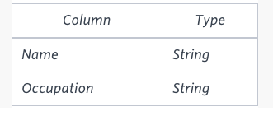

Occupation will only contain one of the following values:

Doctor, Professor, Singer or Actor.

***Sample Input***

An OCCUPATIONS table that contains the following records:

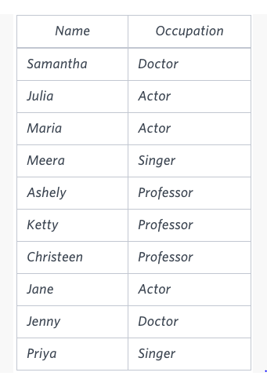***Sample Output***

Ashely(P)

Christeen(P)

Jane(A)

Jenny(D)

Julia(A)

Ketty(P)

Maria(A)

Meera(S)

Priya(S)

Samantha(D)

There are a total of 2 doctors.

There are a total of 2 singers.

There are a total of 3 actors.

There are a total of 3 professors.

**Implement the above experiment and submit it**

**Query 1 :**

**mysql>** select CONCAT(CONCAT(CONCAT(Name,"("),substr(Occupation,1,1)),")")

**->** as "Name(Occupation)" from Occupation order by Occupation;

+------------------+

| Name(Occupation) |

+------------------+

| Julia(A) |

| Maria(A) |

| Jane(A) |

| Samantha(D) |

| Jenny(D) |

| Ashely(P) |

| Ketty(P) |

| Christeen(P) |

| Meera(S) |

| Priya(S) |

+------------------+

10 rows in set (0.00 sec)

**Query 2 :**

**mysql>** select CONCAT("There are a total of ",count(Occupation)," ",lower(Occupation)) as "No of ManForce in Every Occupation" from Occupation

**->** group by Occupation

**->** order by count(Occupation),Occupation;

+------------------------------------+

| No of ManForce in Every Occupation |

+------------------------------------+

| There are a total of 2 doctor |

| There are a total of 2 singer |

| There are a total of 3 actor |

| There are a total of 3 professor |

+------------------------------------+

**4 rows in set (0.00 sec)**

1. **Learning outcomes (What I have learnt):** 
   * 1. **Learn about Aggregate function**
     2. **Learn about group by clause**
     3. **Learn about having clause with aggregate functions**

**Evaluation Grid:**

|  |  |  |  |
| --- | --- | --- | --- |
| Sr. No. | Parameters | Marks Obtained | Maximum Marks |
| 1. | Demonstration and Performance  (Quiz) |  | 22 |
| 2. | Worksheet |  | 8 |